Dear GRU Members and Friends,
The world is but a canvas to our imagination. - Henry David Thoreau

Greetings from the Board at Grand River Unitarian Congregation. With the advent of fall, our GRU home is buzzing with people and events and the TAB newsletter grows longer each week. We are grateful to celebrate this renewal of spirit and look forward to an exciting congregational year.
Please find attached a summary of your financial contributions to GRU up to the end of September.
In February of this year, the Board presented a budget that reflected an investment in people and programs. We anticipated a deficit of almost $33,000.
In January of this year, we received a generous private donation of $25,106. This has helped to offset the anticipated deficit. Our year-to-date position as of the end of September is a surplus of $967. Without this private donation, we would be showing a deficit of approximately $24,000.
We have been able to keep other expenses low, including our staffing, because of a timing issue. The January payroll was processed in December 2022, so we have one less payroll appearing on our 2023 books.
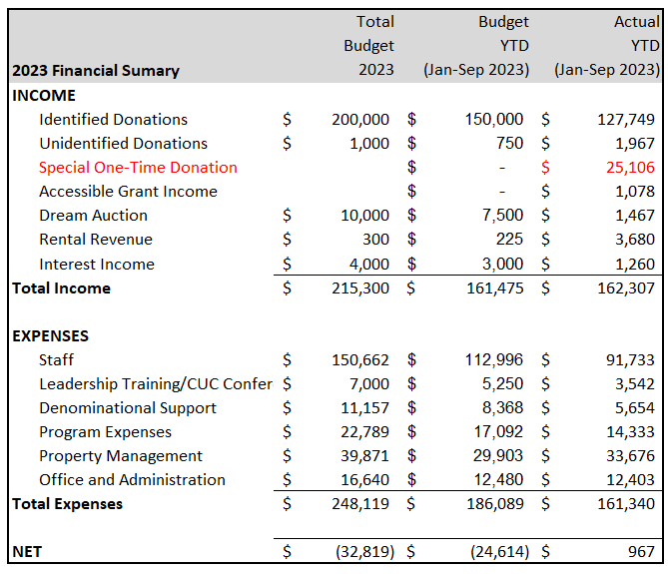

Our regular donations are about $21,000 below budget. The effects from the pandemic, coupled with the rising cost of living, are continuing to impact our financial position.
Our cash reserves remain strong. As of October 10 we have approximately $237,000 in the bank. $160,000 of this is in long term GICs where it is earning good interest.
To paraphrase from Henry David Thoreau, GRU is but a canvas[s] of our imagination. As we settle now into the crispness of autumn weather, we turn our attention to the painting of financial plans for next year. As a self-supporting community, we rely on the financial support of our members and friends.
For this Canvass, we ask you to consider what GRU means to you. Can you imagine increasing your contribution in the coming year? How might you help ensure that GRU can continue to offer programs that provide spiritual nourishment and support for our beloved community in the coming year?
Please review your statement of donations to see what you pledged last year.
Pledge forms and regular monthly donations help us make more concrete financial plans. We ask you to:
- Fill in a pledge form and send it back to us.
  - It is included in this mailing.
  - You can email the completed form to donate@grandriverunitarian.ca or mail it. The mailing address is 299 Sydney St. S., Kitchener, ON N2B 3V8.

- Consider committing to a regular, preauthorized donation through your bank. If you are able to do this then:
  - Fill in the preauthorized donation form included in this mailing.
  - You can email the preauthorized completed form to donate@grandriverunitarian.ca or mail it. The mailing address is 299 Sydney St. S., Kitchener, ON N2B 3V8.
If you have any questions, please reach out to any member of the Board or contact the office at 519-742-0432.
Thanks and take care,
The GRU Board:
Wendy Martin, President | Cathy Scott, Vice-President
Carol Burrows | Anne Dahmer
Susan Patterson | Tim Pincura O’Neil
Tom Nagy

